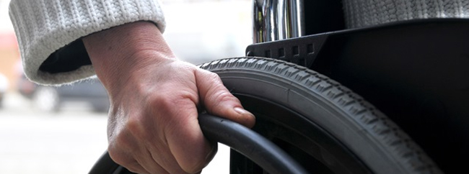

**Redesigning the Flying Experience for Persons with Disabilities**

Mechanical Engineering 310 Winter Quarter

Team Team: Embraer

Rodrigo Aquino, Clifford Bargar, Maria Barrera, Luiz Dur}ao, Erika Finley,

Laura Hoinville, Robert Karol, Guilherme Kok, Amanda Mota

Mechanical Engineering Design Group

416 Escondido Mall

Stanford University

Stanford, CA 94305-2203

http://me310.stanford.edu

March 17, 2014